Using Decision-Theoretic Models to Enhance Agent System Survivability
Anthony Cassandra, Marian Nodine, Shilpa Bondale, Steve Ford and David Wells
Abstract— A survivable agent system depends on the incorporation of many recovery features. However, the optimal use of these recovery features requires the ability to assess the actual state of the agent system accurately at a given time. This paper describes an approach for the estimation of the state of an agent system using Partially-Observable Markov Decision Processes (POMDPs). POMDPs are dependent on a model of the agent system – its components, environment, sensors, and the actuators that can correct problems. Based on this model, we define a state estimation for each component (asset) in the agent system. We model a survivable agent system as a POMDP that takes into account both environmental threats and observations from sensors. We describe the process of updating the state estimation as time passes, as sensor inputs are received, and as actuators affect changes. This state estimation process has been deployed within the Ultralog application and successfully tested using Ultralog’s survivability tests on a full-scale (1000+) agent system.
- Introduction

This paper describes the approach for estimating the state of an agent system, i.e., the composite state of its agents and other components, as implemented within the Ultralog [Ultralog] Adaptive Defense Coordinator (ADC) [WPCN04]. A key aspect of the Ultralog system is its resilience to failures and attacks. The Ultralog application is a long-running logistics application that can be distributed over a very large agent society. This society is assumed to exist in an unstable environment, both from the prospect of natural and externally induced failures. The application has been tested in environments with high failure rates, under the assumption that the logistics application itself must run correctly, despite all of the failures.
In Ultralog, resilience to failure is accomplished using a variety of independently developed security- and robustness- oriented defense mechanisms, some of which operate in a proactive and some in a reactive manner. Within the defenses, sensors detect problems within the agent system, and actuators respond with some remediation action. For example, an agent health sensor may detect that an agent has failed, and a restart action will restart that agent. Alternatively, if there is an elevated security threat, an action may be taken to raise encryption levels for messages between certain agents.
While it is desirable for numbers of independently-developed sensors and actuators to be able to effect changes in an agent system, this approach introduces the additional problem that the sensors and actuators may interfere with each other, causing the outcome of their operation to be destructive rather than constructive. For instance, an agent may deliberately disconnect itself temporarily, but a “liveness” sensor may report the agent “down”, possibly causing an inappropriate decision to restart the agent on another machine.
The Adaptive Defense Controller (ADC) presides over the sensors and actuators. It considers the entire set of sensor outputs that it receives, and attempts to determine an overall picture of the state of the agent system, and its components. Based on this overall picture, it may enable one or more non-conflicting actions at any given time, aiming to improve the overall health of the agent system.
In this paper, we examine a key component of the ADC, which has responsibility for examining the collection of sensor and actuator outputs to assess the state of the agent system and its components. The ability to make intelligent choices concerning which actions to take is predicated on the accuracy and comprehensiveness of the estimation of the system state. We use the term state estimation to describe this process of assessing system state.
This paper is organized as follows: Section 2 describes the model of the agent system over which state estimation operates. Section 3 provides a formal model of Ultralog as a POMDP, and how environmental state transitions and observations fit into the model. Based on this information, section 4 describes how state estimations are updated. Section 5 provides more detail on environmental threats and their effect on the computation. Section 6 summarizes our experiences with this approach in an operational system.
- Modeling the Agent System
State estimation operates over a domain model representing the agent-based system, its operational environment, and its applications. At the heart of the domain model is a notion of an asset. Assets are distinguishable, monitored entities within the agent-based system. An asset can be an agent, a node that agents reside on, or other elements of the infrastructure which affect agents. Each asset has a specific type – examples of asset type include agents, nodes and hosts. The state of an asset is monitored using one or more sensors, each which observes a specific asset, and provides a diagnosis. The state estimation process involves examining the collective set of diagnoses for a given asset to obtain an overall, composite view of the state of that asset. An actuator is an entity that can affect the state of an asset. If an asset is not in a “good” state, then one or more actuators may be invoked by the ADC in an attempt to rectify the problem.
The environment in which the agent-based system is running is modeled using threat models. Threats are environmental factors that may affect assets, such as natural computer failures or deliberate attempts at security compromise. Each threat may (with some probability) cause one or more events, the effects of which may correspond to an actual change in the state of some asset. Effects may be transitive – for instance, if a node fails, then all of the agents that reside on that node also will fail. Aside from directly affecting the state of an asset, an event could also trigger other events that would in turn affect other assets.
In the following subsections, we will go into more specific detail about the different aspects of the domain model that are used during state estimation.
  - Asset Types and Asset State Estimations
The asset type model provides the modeling information necessary to describe the state of an asset. Each asset type model is composed of a set of state dimensions that capture the salient attributes of the asset. Fig. 1 shows a sample containing a subset of the state dimensions for an asset of type Agent used in the Ultralog project. The state dimensions for the Agent asset type shown in the figure include:
- Liveness, indicating whether the agent is live or dead,
- Connectedness, indicating the agent's state with respect to wanting to disconnect or reconnect (e.g., as a result of a desire to move),
- UnmediatedConnectionStatus, indicating the nature of the best existing path to the asset.
Each state dimension defines several states related to the specific aspect of the agent that it models. For instance, as shown in Fig. 1, the Connectedness state dimension contains states representing known needs to disconnect and reconnect. These states are self-explanatory with the possible exception of Tardy, which indicates that the agent has been disconnected for longer than the time frame that it specified in a request to disconnect.
The set of states in an asset state dimension is always discrete. If a state dimension, such as one indicating the CPU load, is continuous, the range can be discretized, e.g., to Low, Medium and High, or finer resolutions as needed.
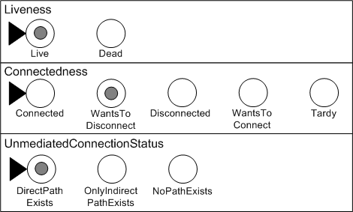
Fig. 1. Asset State Example
In this work we make the simplifying assumption that state dimensions are orthogonal and undergo changes independent of one another. The full state of the asset shown in Fig. 1 is Live, with a direct path to it, and has indicated that it wants to disconnect.
Note that the state dimension definitions do not include any state transitions. This is deliberate, as these transitions relate more directly to threats and actions, as opposed to assets and therefore will be covered under other aspects of the model.
The salient feature of the asset model is its representation of containment relationships among assets. For instance, an agent resides on a node, and if anything happens to the node, there will be an effect on the agent. These transitive effects are discussed in the context of the ensuing sections.
  - Representing Estimated State
Due to uncertainties related to the environment, the sensors, and the agent system, it is rarely possible to get a definitive understanding of the true state of a given agent at a specific time. Instead, we use a state estimation for an agent defined as a probability distribution across the states in each dimension. An example state estimation for a specific agent is shown in Fig. 2. We can conjecture that this agent is likely in the state that was shown in Fig. 1; however, there are other less likely possibilities that may also be the case. These probabilities reflect the uncertainties associated with the asset's environment, including uncertainties about diagnoses, threats, events, and actuator effects. Subsequent sections will describe how these state estimations are derived.
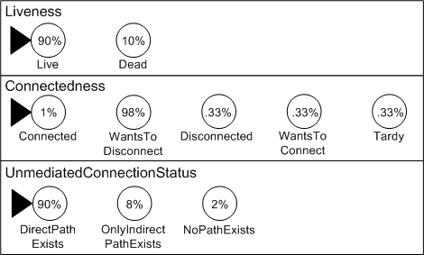
Fig. 2. Example of a State Estimation
  - Sensor Models
In order to keep the agent system operational, the ADC must constantly observe the assets to determine whether any reactive or preventive actions are needed. This feedback is provided via a set of sensors, each of which has the responsibility of monitoring a particular state dimension of an asset. Different types of assets will have different types of sensors. For some assets, it may be useful to define multiple sensors for the same state dimension, since different sensors can have varying levels of fidelity depending on its characteristics.
An important aspect of the sensors is that the set of possible sensor output values (called diagnoses) may not have a direct one-to-one mapping to the set of state dimension values for the asset being monitored. Additionally, due to the distributed nature of the Ultralog agents, the delays inherent in digital data networks, and the outages due to spurious, accidental or deliberate actions, the diagnoses received from the sensor may not be accurate or reliable. Thus, the sensor model must also include information on the sensor latency and accuracy. Note that this means that the asset states themselves are hidden, since we may never be certain of its state due to the inherent noise in the sensor diagnoses.
Fig. 3 shows an example model for a hypothetical AgentHealthDiagnosis sensor that tries to determine the health of an agent. It senses along the Liveness state dimension, but its values do not correspond exactly to the states in that state dimension. The probabilities related to how the sensor outputs affect the state estimation fold together both (a) the mapping from the sensed values to the states in the sensed state dimension and (b) any sensor inaccuracies. Thus, in Fig. 3, when the actual state of the agent is Live, the sensor will output Up 70% of the time, Degraded 25% of the time, and Down 5% of the time. Similarly, when the agent is actually in the Dead state, the sensor will output Up 5% of the time, Degraded 10% of the time, and Down 85% of the time.
  - Models of the Environment
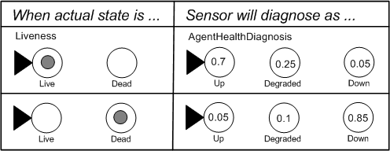
Fig. 3. A Conditional Probability Model for a Sensor
In the logistics environment, inadvertent or deliberate actions outside the control of the ADC can cause assets to undergo a state change. External sources that can affect the state of some asset or assets are called threats. Threats are not predictable; rather, they represent the potential for something (bad) to happen. For each threat there is a time-dependent probability that the threat will actually cause an event to occur. At any point in time, there are usually a large number of threats, each having the potential to cause some event. It is the events can have a direct effect on the asset’s state. Initially, each individual event defined in the model is limited to affecting only one of the state dimensions of an asset, though any number of events may cause a state transition for a given state dimension.
An example of threats and events is shown in Fig. 4. The likelihoods of occurrence of threatened events are defined as a function of the amount of elapsed time. In the given time frame, there is a 10% chance that an AgentVirus threat will cause an AgentDeath event. Other ways AgentDeath may happen are if the node gets a virus, causing a NodeDeath on the node on which the agent resides, or the host on which the agent’s node resides could be bombed, causing a HostDeath event. Also shown in Fig. 4 is a case where events have transitive effects and cause other events. Due to the relationships between an agent, its node, and its host, any of these events may cause (directly or transitively) an agent to transition from the Live state to the Dead state along the agent's Liveness state dimension.
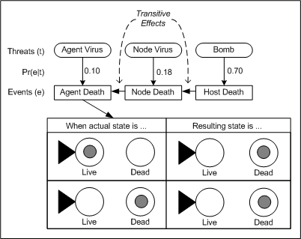
Fig. 4. Threats, Events and State Transitions
Currently, a given event can only have one transitive effect, and the transitive effect always occurs if the event occurs. However, transitive effects can cross state dimension and event asset type boundaries. That is, an event that affects a node's Liveness state dimension may have a transitive effect whose resulting event is on the Connectedness dimension of a node, or even on the Connectedness state dimension of a different type of agent.
The state estimation process combines the likelihood of a given state transition over multiple (possibly transitive) events to get an overall probabilistic model for how an asset's states may change in the modeled environment a given interval of time. The details of this combining process are discussed in later sections.
  - Actuator Models
The main purpose of the ADC is to take reactive and preventive actions to improve the overall state of the Ultralog agent system. This requires defining a set of control options available to the ADC as it deliberates about what, if any, actions should be taken in a given state.
We model these control options with a set of actuators, which represent the actual software/hardware objects that can effect changes in the states of assets along state dimensions. Fig. 5 illustrates the Restart action, whose purpose is to transition an agent to the Live state from its current state
- Formal Modeling
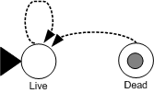
Fig. 5. State Transitions for Agent-related Actuators
The individual models discussed for the assets, sensors, environment and actuators are the components of an overall model of the assets in the Ultralog system. The discrete, probabilistic nature of these components and the inherent hidden state of the assets, make the partially observable Markov decision process (POMDP) model [CKL94] a very good way to formally capture all these components. We adapt the POMDP model framework to the specifics of the ADC requirements, allowing us to leverage existing state estimation techniques for these models.
Generally, POMDP models are created with the intent of using automated techniques for finding optimal or near optimal policies of action. In the ADC, we use the POMDP model as a useful framework for calculating state estimations in discrete models with hidden state. However, we use heuristic techniques, rather than computing the optimal policy, to determine the ADC actions.
To keep the complexity of the model to a manageable size, we use a series of independent POMDP models, one for each state dimension of each asset type. This makes a relatively strong assumption about the independence of asset state dimensions, sensors, events and actuators. Future work will look into relaxing these assumptions for specific important cases. Generally, if no independence assumptions were made, then the number of environment parameters needed to specify a complete model for the Ultralog domain would be prohibitively large.
  - Ultralog as a POMDP
In a POMDP model, there are three discrete sets: states, actions and observations. The states of the POMDP model become the set of possible values of the asset’s state dimension. The actions are directly modeled as the set of Ultralog actuators, and the observations are the sensor diagnosis values.
There are also two functions that comprise the POMDP model: a state transition function and an observation function. A state transition function maps combinations of actions, initial states and end states into probabilities. The observation function maps combinations of actions, states and observations into probabilities. These two functions capture all the uncertainty and provide enough information to allow the computation of state estimations for the underlying states of the model. We omit the reward structure usually present in a POMDP model because we are currently only concerned with using the POMDP for state estimation. The ADC does use a utility function to guide its heuristic action selection, but the function does not get used in computing state estimations.
  - State Transition Functions
The POMDP model parameters for the state transition function are: 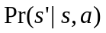whereis the current state,the ending state andis the action. In the Ultralog model, there are two separate conditions under which assets can undergo state transitions: threat-based event occurrence and actuator usage.
The actuator-based state transitions are directly modeled as shown in Fig. 5 so that each action corresponds to one of the actuators. Most of the currently implemented Ultralog models use deterministic state transitions for the actuators, though our development of the state estimation computations makes no such assumption.
We have chosen to keep the actuator-based and threat-based transitions separate in the state estimation calculation, so that threat-based transitions are not dependent on the action (actuator) chosen. Thus we have 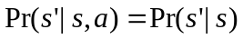for threat-based state transitions. In fact, the probabilities of state transitions due to threats are also time-dependent, something not normally present in a POMDP model. While this time dependency would be a source of problems if we were to attempt to use the model to derive action policies, this is not the case when we are only using the POMDP for state estimation.
Unlike the actuators, we cannot directly specify the POMDP model parameters for threat-based state transitions. Instead, the transition probability must be computed based on , the elapsed time, and , all the events that could affect the asset. This means that 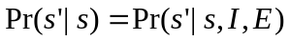. Since there are potentially many events involved, including transitive events, the formulas for computing these probabilities is deferred until Section 5.
  - Observation Functions
The observation function parameters of a POMDP are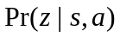 whereis a state,an observation and the action. Each observation corresponds to a sensor diagnosis value and we assume that these are not dependent on the action chosen, 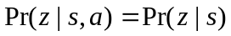. These conditional probabilities are modeled directly as the sensor accuracy parameters as shown in Fig. 3.
- The Process of State Estimation
For each asset, the ADC keeps a state estimation and continually updates this as it receives new information and as time passes. The initial state estimation for an asset is explicitly given in the model and usually reflects a “good” initial state. There are two system situations which trigger the ADC to update the state estimation for an asset:
- sensor diagnosis arrival, and
- actuator completion.
Both of these occur at distinct points in time and since threats are always present, both these state estimation calculations must also account for the possible effects of these threats over time. Therefore, the state estimation computation consists of two phases. The first phase updates the state estimation to account for the passage of time since the last state estimation, while the second phase incorporate the newly arriving information, either the diagnosis or the actuator result.
  - Updating for the Passage of Time
The model explicitly expresses a probability distribution (usually an exponential distribution) of the mean time between threat-induced events. This is used to calculate the probability of a given threat causing a given event over a given time interval of elapsed time, . Using these probabilities and the model-specified relationships between threats, events, transitive effects and assets, we can compute the probability of an asset transitioning from state to state in interval , 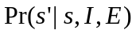. We defer the details of this computation to Section 5, but once this quantity is calculated, we can update the state estimation using.
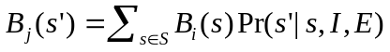.
Here,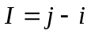. 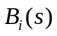represents the last computed state estimation for state, which occurred at time . 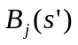represents the new state estimation for asset state at time . This expected value calculation, done over the set of all asset states , needs to be computed for all.
  - Updating for Diagnoses
The receipt of a diagnosis at time first triggers an update of the state estimation for the passage of time as shown in subsection 4.1. Next we incorporate the sensor model parameters 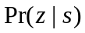into the state estimation using
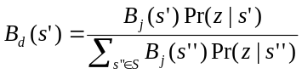
This is a direct application of Bayes Theorem, computing the probability that we receive diagnosis if we are in state divided by the expected probability we would receive observation from all possible states.
  - Updating for Actuator Effects
This part of the state estimation computation is the simplest. Again, 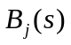must first be calculated as shown in subsection 4.1, to account for the threat-induced state transitions. Then, we can use the actuator model parameters 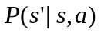directly for an action arriving at time to calculate 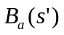:
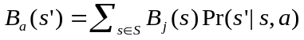
- Threats, Events and Transitive Effects
This section addresses the problem of computing the probability of an asset transitioning from state to state in interval , . Note that, because threats are ongoing and time-dependent, state estimation must account for every threat over every interval of time, for every state dimension of every asset. Whenever a state update is triggered due to diagnosis arrival or actuator effect, this accounting takes place before the triggering information is considered. The ADC accomplishes this by computing a state transition function for each affected state dimension of the asset. This state transition function provides the probability of transitioning from stateto state, for every pair of states 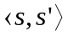 in every affected state dimension of the asset. Because of causality relationships, this computation requires looking at the complete set of threats, events and transitive effects to determine what can impact a given asset's state dimension. In particular, while events are the things that can directly affect the asset, they can be directly or transitively caused by threats. To complicate matters, a given state dimension for an asset can be affected by multiple events, and each individual event could be caused by multiple threats. Fig. 6 shows these relationships, though omits showing transitive effects since these will be treated separately.
  - State Transition Computations
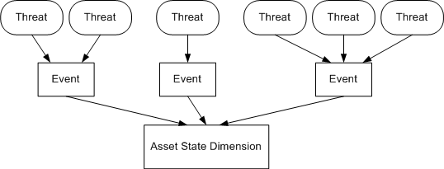
Fig. 6: Multiple Events and Threats
Let be the set of its possible values in a given state dimension of an asset. Assume that this state dimension is affected by the set of events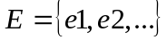. For each of the individual events,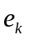 let the set 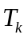 be the set of threats that can cause that event. We are concerned with finding the state transition probability function, 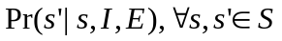 where is the interval of time over which the threats were acting. In this subsection we first derive the formula under the assumption that there are no transitive effects. In the subsequent subsection, we show additional computations required to handle transitive effects.
For the set of events that could cause state changes to the asset, at a given instance of time we must consider all of those events that actually did occur. Because these events are external and not directly observable, we can never be certain of exactly which events occurred. So we compute the expected likelihood of the transition using model parameters. By the law of total probability, we have
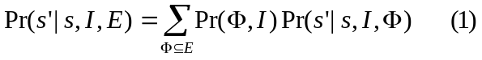
This considers state transitions for all possible subsets of the events that could occur, along with the probability of each subset occurring. We can then calculate the conditional probability of the state transitions for each combination and arrive at the expected probabilities that the asset will move to state given it starts in state.
Computing the probability that a given subset of events occurs, 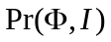, requires the assumption that the events in the setare independent. Without such an assumption, the model would need to capture the full joint distribution over all possible subsets of events, which would seriously complicate the model. Instead, when the joint probability is required due to multiple events occurring, we estimate it by averaging all the individual state transitions for each event that occurred.
For similar reasons, we also assume that all threats are mutually independent and that it does not matter how many of the threats in cause event ; any single threat or combination of one or more threats is sufficient for the event to occur.
For a given subsetof events from E, the probability that they occur is computed by:
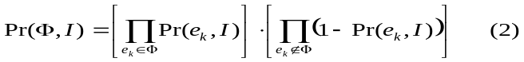
Here, under the assumption of independence, we take the product of the probabilities of those events that are in the set and the complement of the probabilities for those that are not in the set.
The remaining computation 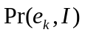, requires combining the probabilities of all the threats that can cause the event. Given the elapsed time,, the model directly provides the individual values 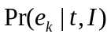for the probability that threat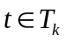will cause event. Because we assume that any one threat or combination of threats in is sufficient to cause the event , we can compute the probability of the event by computing the probability that none of the threats occur, and subtracting the result from 1:
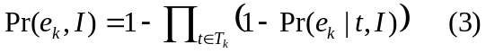
Thus, starting with the model parameters,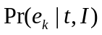and applying Equations (2) and (3), we can compute the probability of a given subset of events occurring.
The only remaining calculation needed to complete Equation (1) is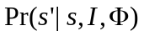, the probability of the state transition given a subset of events. We compute this approximation to the joint distribution using:
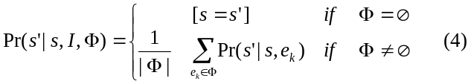
The notation 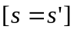, derived from[GKP89}, is defined as:
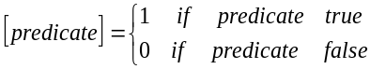
In words, Equation (4) says that if there are no events that can affect the asset, then the asset will not change state due to threats. If at least one event occurs, the transition probability is computed as the average of all the individual transition probabilities for each occurring event in . The quantity 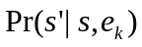is explicitly specified as part of the event model for each event and is not dependent on time, so does not require conditioning on the interval.
  - Transitive Effects
The previous subsection only considered the case where threats directly caused events. Therefore, the parameterwas directly available in the threat model. However, the actual situation looks more like Fig. 7 and requires the probability of an event occurring to take into account both threats and transitive effects.
Instead, we need a more general form of Equation (3) given by
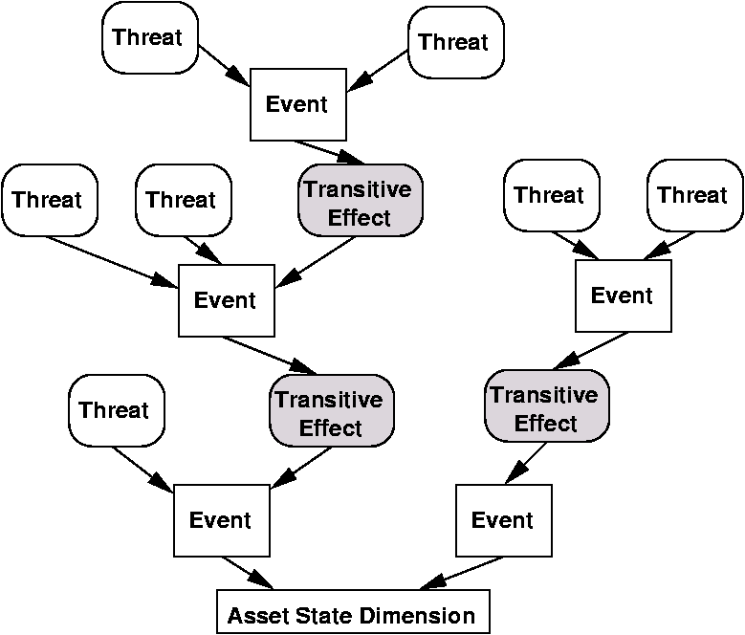
Fig. 7: Threats, events and transitive effects.
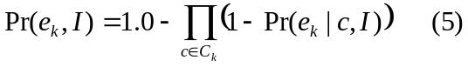
Here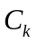is the set of causes of event , which will consist of a combination of threats and transitive effects. For the case where there are no transitive effects, the setis the same as the set described previously and Equation (3) can be used.
For any threats that happen to be in the set of causes , we have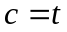 and 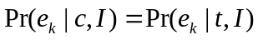 so can use the threat model parameters directly. When cause is instead a transitive effect, 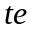, we need to multiply the probability that the transitive effect causes the event by the probability of the transitive effect occurring:
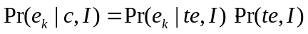
The quantity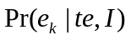is another model parameter that, like the threat probability, specifies the probability that the transitive effect causes the event over some interval of time and given that the transitive effect actually occurs. However, we must derive 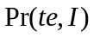, the probability that the transitive effect occurs by looking at the event that causes it.
Because an event deterministically causes its transitive effects when it occurs, the probability that a transitive event occurs equals the probability of the parent event occurring. Letting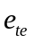 be the event that causes transitive effect gives:
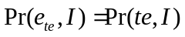
and we use Equation (5) recursively to compute the probability of event by letting 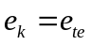. We continue to recursively compute event probabilities until it grounds out in threats with explicitly modeled probabilities.
- Modeling Experiences
This paper has developed the necessary model components and calculations needed to produce state estimations for the ADC. The implementation of these in an actual working system posed numerous challenges and required a significant amount of refinement to overcome as the development proceeded. Among the more interesting issues that were dealt with in the ADC were related to timing, scaling, and derivation of model parameters.
The timing issues that arose in the development of the ADC are too involved to discuss here in depth. However, a very important issue was ensuring that neither too many nor too few state estimations were produced. This required both caching diagnoses to produce “bulk” state estimation updates when observations were frequent, and setting alarms to force periodic state estimation updates when observations were sparse. A second operational requirement was delaying state estimation updates and setting timers to mitigate issues of varying sensor latencies.
An important scaling issue concerned reducing network chatter. Since hundreds of sensors were reporting diagnoses on an ongoing basis, some were implemented to only report a diagnosis if it was different from the last diagnosis sent to the ADC. The ADC then needed to assume implicit diagnoses during the state estimation update to ensure that this information was made explicit for the ADC analysis.
Setting the various model parameters required domain expertise to provide the estimates for the various probabilities of threats, events, diagnoses and actuator accuracy. The exactness of these values was not crucial, as the ADC was only using heuristics to select actions, but often times required a few iterations of examining the system behavior to converge on useful values. We also learned that it is generally bad to use zero probabilities, as this makes a very strong statement about the impossibility of events or diagnoses. In a large agent system, regardless of how improbable something is, few situations are actually impossible and dire results occur if mistakenly modeled as such.
- Related Work
Defense coordination has been addressed by Ultralog for several years. Both Brinn and Greaves [BG03], and Helsinger et.al. [HKB04], have described the overall Ultralog approach to survivability. The description in Helsinger et.al. used an earlier, more narrowly-scoped version of the technology described in this paper. The basic architecture and function of the Adaptive Defense Coordinator as it exists today is described in [WPNC04].
POMDPs have been used extensively in the robotics community as a model for performing state estimations including [SK95], [NPB95], [CKK96] and [FBT99]. Other researchers have applied similar techniques to other application domains, including electrical grid failure diagnosis [Th96], military mission planning [Yo98], inspection and maintenance policies [EJC95], gesture recognition [DP96] and behavioral ecology [MC88].
- Conclusions
The goal of this work is to provide a means to accurately assess the state of an agent-based system, in terms of the states of each of its components, and to use this to enhance system survivability in the face of significant levels of failure and uncertainty in the operational environment. Our approach uses decision-theoretic models to provide state estimations in a large agent system. Though system-specific constraints required adapting the model and making independence assumptions, we were still able to implement and use the existing theory for these models towards the survivability goal.
To test our theories, we implemented this approach within the Ultralog application. This implementation of state estimation was embedded within the Ultralog Adaptive Defense Coordinator, and worked in conjunction with heuristic techniques for selecting recovery actions to control the use of defenses that maintain agent system health and survivability. This solution was tested as a part of the Ultralog survivability testing on a system of 1000+ agents.
Future work will be predominantly geared toward relaxing the independence assumptions made in this current work. We have identified a few important aspects of the Ultralog system that are tightly coupled. While we were able to handle this coupling with some slight adaptations to the existing model, a solution that does not require these assumptions would be more accurate. A second situation where independence may be a problem is when a threat and an action occur simultaneously, and may interfere with each other (either constructively or destructively). A separate issue to address in the future is that some diagnoses “dominate” others – an example in Ultralog was a planned disconnect. In this case, the current approach was somewhat slow to adjust the belief state for the asset to reflect what was meant to be a very certain diagnosis.
- Acknowledgment
This research is sponsored by the Defense Advanced Research Projects Agency and managed by the Department of the Interior/National under contract MDA972-01-C-0025. The views and conclusions contained in this document are those of the authors and should not be interpreted as representing the official policies, either expressed or implied, of the Defense Advanced Research Projects Agency or the United States Government.
The authors also would like to acknowledge the many UltraLog project members who have contributed ideas and suggestions, including but not limited to Mark Greaves, Marshall Brinn, Michael Thome, Aaron Helsinger, and Steve Ford.
- References
[BG03] M. Brinn and M. Greaves. Leveraging Agent Properties to Assure Survivability of Distributed Multi-Agent Systems. In Proc. Int’l Conference on Autonomous Agents and Multi-Agent Systems, July, 2003.
[CKK96] A. Cassandra, J. Kurien and L. Kaelbling. Acting Under Uncertainty: Discrete Bayesian Models for Mobile Robot Navigation. IEEE Conference on Intelligent Robots and Systems, 1996.
[CKL94] A. Cassandra, L. Kaelbling and M. Littman. Acting Optimally in Partially Observable Stochastic Domains. In Proc. of Twelfth National Conference on Artificial Intelligence, 1994, pp. 1023-1028.
[DP96] T. Darrell and A. Pentland. Active Gesture Recognition using Partially Observable Markov Decision Processes. IEEE Conference on Pattern Recognition, 1996.
[EJC95] H. Ellis, M. Jiang and R. Corotis. Inspection, Maintenance and Repair with Partial Observability. Journal of Infrastructure Systems, 1995.
[FBT99] D. Fox, W. Burgard and S. Thrun. Markov Localization for Mobile Robots in Dynamic Environments. Journal of Artificial Intelligence, 1999.
[GKP89] R. Graham, D. Knuth and O. Patashnik. Concrete Mathematics, Second Edition. Addison Wesley, 1989.
[HKB04] A. Helsinger, K. Kleinmann and M. Brinn. A Framework to Control Emergent Survivability of Multi-Agent Systems. In Proc. Int’l Conference on Autonomous Agents and Multi-Agent Systems, July 2004, pp. 28-35.
[MC88] M. Mangel and C. Clark. Dynamic Modeling in Behavioral Ecology. Princeton University Press, 1988.
[NPB95] I. Nourbakhsh, R. Powers and S. Birchfield. DERVISH: An Office Navigating Robot. Artificial Intelligence Magazine, Summer, 1995, pp. 53-60.
[SK95] R. Simmons and S. Koenig. Probabilistic Navigation in Partially Observable Environments. International Joint Conference on Artificial Intelligence. Montreal, 1995.
[Th96] S. Thiebeaux, M. Cordier, O. Jehl and J. Krivine. Supply Restoration in Power Distribution Systems. In Proc. of Twelfth Annual Conference on Uncertainty in Artificial Intelligence, 1996, pp. 525-532.
[Ultralog] DARPA UltraLog Web Site. http://www.ultralog.net.
[WPNC04] D. Wells, P. Pazandak, M. Nodine and A. Cassandra. Adaptive Defense Coordination for Multi-Agent Systems. In Proc. IEEE Symposium on Multi-Agent Security and Scalability, August, 2004.
[Yo98] K. Yost. Solution of Sequential Weapons Allocation Problems with Imperfect, Costly Information. Sixth INFORMS Computer Science Technical Section Conference, 1998.

